This document starts with the name of the External Activity, notes its inputs and outputs and then shows the JSON for a GET request of a task. Finally it shows the response JSON to be passed when the task is completed. Building this notepad document and keeping it handy while designing and coding can save much time and effort.
这个文档是以外部活动的名字开头的，记录了输入和输出参数，并且显示一个任务的GET请求的JSON信息.最终它显示的是任务结束时，用来传递的JSON返回值。在设计和编码时创建这样的记事本文档并且存档，将会节省很多时间。

Completing an External Implementation – Web Service API

实现一个外部实施 - Web Service API
One of the most common use cases for an External Activity will be completing it. To understand this part of the story, imagine that a BPD has reached a BPD activity that is defined as an External Activity. This will create an instance of a Task. Assume that by some means, an external application knows the identity (ID) of this task. The external application now wishes to complete the task. This will involve executing a Web API call called completeTask(). The input to this operation are two parameters:
外部活动中一个比较常见的用户用例是要实现它。为了更好的理解这一部分，可以理解为一个BPD访问一个被定义为外部活动的BPD活动。这将会产生一个任务实例。首先我们假设，外部应用可以获知这个任务的身份特性（ID）。外部应用目前希望能完成这个任务。它将会执行一个completeTask()的Web API调用。该操作的输入包含两个参数：
- The identity of the task to be completed (a variable of type long)
- The output variables to be associated with its completion (an array of Variable)
- 要完成的任务的身份特性（一个long类型的变量）
- 跟完成操作相关的输出变量（一个Variable数组）
Since in this story, we are already assuming that we know the identity of the task, the missing component is knowledge about what the output variables should be.
在这样的一个故事里，我们做了假设，已经获取了该任务的身份特性，但我们仍需要了解的是输出变量是怎样的。
When we query and retrieve the Task object for a task, we find it has an attribute called attachedExternalActivity of type ExternalActivityAttachment.
当我们要对一个任务的任务对象进行查询或者获取时，我们发现它提供了一个名为attachedExternalActivity属性，其类型为ExternalActivityAttachment。
(Note: It is the authors belief that the concept of two names here is confusing. He believes that "attached external activity" is the correct name as the notion is that of external activity being attached (or associated) with a Task.)
（注释： 作者相信这两者命名的概念有点让人混淆。他认为这个“附加外部活动”是正确的名字，因为外部活动是附属于（关联到）一个任务的。）
This structure looks as follows:
它的结构如下：
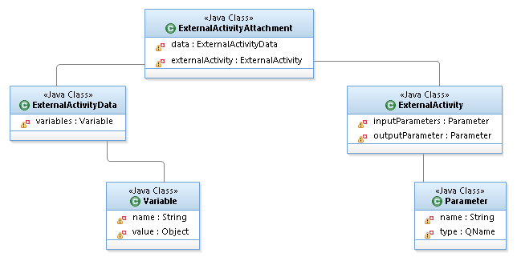
The key to understanding this is that there is an array of Variable objects called data. Each variable consists of a name and a value. If we next look at the input parameters to the Task, we see that those can be found at externalActivity.inputParameters which is an array of Parameter objects. Each parameter consists of a name and type. And here is the tricky/interesting part. For each parameter which has name "X", there is a variable which also has name "X". Thus for each input parameter we can now find its name, type and value. The same is also true for output parameters.
要理解这个结构的一个关键点事，这里有一个名为data的Variable数组对象。每个变量由一个name和value组成。在任务的输入参数中，我们可以在 externalActivity.inputParameters中找到这样的一组参数对象。每个参数由一个name和type组成。这是一个比较微妙/有趣的部分。对于每个参数，假如它的名字为‘X’，那么 同样也有一个对应的名字为‘X’的变量。因此对于每个输入参数，我们可以找到它对应的名字，类型和值。对于输出变量也一样。
Getting mathematical for a moment if we think of the set of names of input parameters and the set of names of output parameters … the union of these two sets will be the set of names of variables.
For parameters of "simple" types, these are self explanatory consisting of the usual suspects. However, if the parameters are complex types, more discussion is needed.
The data type is defined as a QName which is a qualified name consisting of the namespace of the data type and the name of the data type itself. For example:
{http://www.kolban.com}MyDataType
In Java, the value in the Variables of such a field is a "ComplexValue". This Object is a wrapper for DOM/XML data. It has a property in it called _any which can be retrieved with get_any() and set with set_any(). The data type of this property is a W3 DOM Element.
在Java中，拥有这样属性的变量值是一个“复杂的值”。该对象是一个DOM/XML数据的封装。
Here are some useful tips with working with one of these:
以下是一些工作中常用的信息：
To convert to an XML String (in Java), use the following:
可以使用以下方法来转换XML String(在Java中)：
ComplexValue complexValue = (ComplexValue)value;
Element e = (Element)complexValue.getAny();
DOMImplementation domImplementation = e.getOwnerDocument().getImplementation();
DOMImplementationLS domImplementationLS =
(DOMImplementationLS)domImplementation.getFeature("LS", "3.0");
LSSerializer lsSerializer = domImplementationLS.createLSSerializer();
System.out.println(lsSerializer.writeToString(e));
(Note: The DOM "LS" functions are "Load and Save" and are documented at W3 here:
http://www.w3.org/TR/DOM-Level-3-LS/load-save.html
)
(注释: DOM “LS”函数是“Load and Save”，相关的文档可以参考W3：
http://www.w3.org/TR/DOM-Level-3-LS/load-save.html
)
To create a new output variable is a little trickier. Remember that a Variable consists of two fields,the name and the value. The value field is an Object. If the output type is a complex type then we need to create a ComplexValue object instance and set the Variable's value field to be the ComplexValue. We also need to set the data into the ComplexValue. Remember that this has a set_any() method which expects a W3 DOM Element.
创建一个新的输出变量有点棘手。一个变量包含两个字段：名称和值。字段的值是一个对象。如果输出类型是一个复杂的类型，那我们需要创建一个复杂类型的对象实例饼设置变量的值的字段仍为复杂类型。它提供了一个需要W3 DOM元素set_any()的方法，。
Let us imagine that we have a data type that looks as follows:
假设我们有数据类型如下:
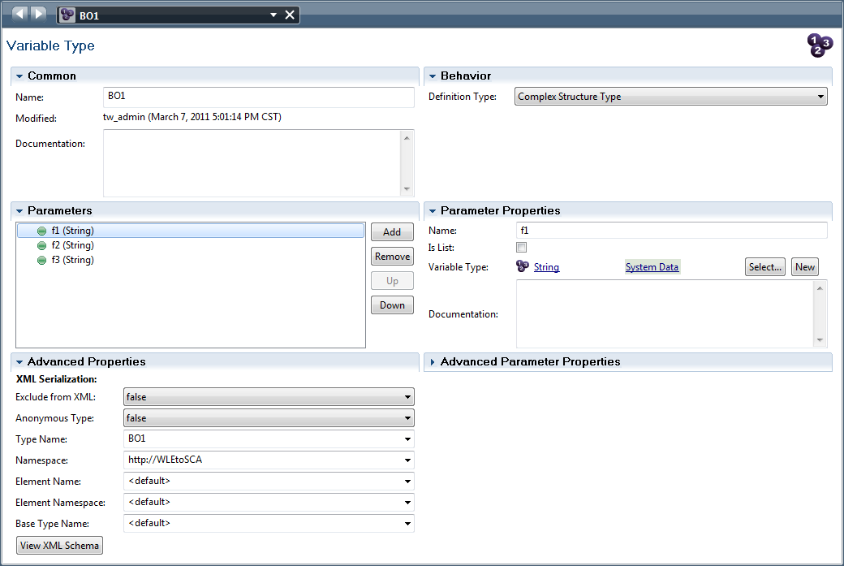
Notice that we have expanded the Advanced Properties so that we can see them in more detail. By clicking on the View XML Schema button we can see the XML Schema for this data type. Now we have all the pieces we need. An example of a good value for BO1 encoded as XML would be:

<?xml version="1.0" encoding="UTF-16"?>
<ns4:BO1 xmlns:ns4="http://WLEtoSCA">
<ns4:f1>f1Value</ns4:f1>
<ns4:f2>f2Value</ns4:f2>
<ns4:f3>f3Value</ns4:f3>
</ns4:BO1>

When we set the ComplexValue's any field, we need to set this to be a W3 DOM Element that represents this piece of XML.
当我们要对ComplexValue的任何字段赋值时，我们需要设置它为一个W3 DOM元素。
Notes:
• The author has not tested this scenario with code, so this is pure theory
• There may be an IBPM utility function supplied called ClientUtilities.toComplexValue() which may be of assistance in building this out
注释：
- 作者并没有通过代码来测试这样的场景，这支持纯理论
- IBPM使用程序ClientUtilities.toComplexValue() 或许对此构造有些帮助

应用程序循环 - Application Loops
Sometimes it is desirable for an activity to be executed a number of times in a loop. In the General properties of an Activity definition, there is a Loop Type indicator in the Behavior section of the panel:
有时最理想的是一个活动执行一个循环的次数。在一个活动的一般属性定义里，在行为面板部分有一个循环类型标志。
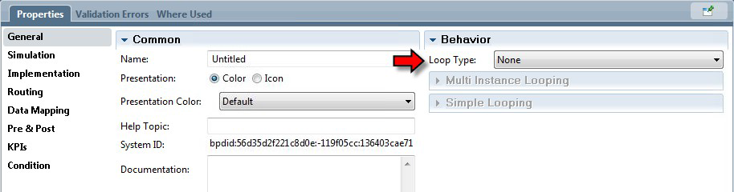
The choices available are:
• None – No looping is to be performed
• Simple Loop – Looping is to be performed one item at a time
• Multi Instance Loop – Looping is to be performed in parallel
可选择的选项有：
- None - 不需要执行循环
- Simple Loop - 循环每次只能执行一项
- Multi Instance Loop - 循环可以并行地执行
The default is None which simply means that there will be no looping. There is nothing further to say on that topic.
默认的值为None，表示不需要执行循环。此次无需赘言。

简单循环 - Simple Looping
With simple looping, the activity is executed a number of times in succession. The number of times the activity is executed is based on the value of the Loop Maximum field which may be an expression or variable resulting in an Integer value. The optional Loop Condition is a boolean expression that is evaluated prior to the next occurrence of the loop. If the condition evaluates to false, the looping terminates early.
通过一个简单循环，一个活动被连续执行了一定的次数。活动执行的次数是基于循环最大字段的值，它可以是一个整型的表达式或者变量。可选的循环条件是一个布尔表达式，用来计算下一个循环循环。如果执行条件的返回值为false，则循环终止。
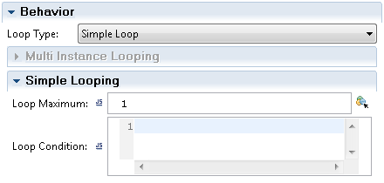
When a simple loop has been added to an activity, the icon representing the activity is updated at the bottom left to show that it contains a simple loop:
当一个简单循环添加到一个活动中，该活动的左下角将会有一个更新的图标，标识着它包含了一个简单循环。
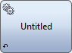
To pass data into the implementation of the activity, the local variable called tw.system.step.counter contains the current loop index which can be used (if needed) to index into a list. For example, in the Data Mapping section of the properties for the activity, we
could code:
通过数据传值给活动的实现，本地变量tw.system.step.counter包含了一个当前循环的指标（如果需要）可以用来标识索引列表。例如，在活动属性里的数据映射部分，我们可以用以下编码：
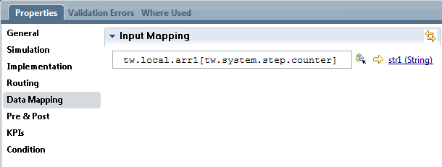

to access the current index of a variable array.
来访问当前变量数组的索引。

多实例循环 - Multi-Instance Looping
Multi-instance looping allows for the activities in the loop to execute in parallel with each other. Another way of saying this is that the activities will execute concurrently.
多实例循环允许并行循环地执行活动。另一种说法是，多个活动可以并发地执行。
When a Multi Instance loop has been added to an activity, it has an icon that indicates this in its lower left:
当一个多实例循环被添加到活动中后，该活动的左下角将会有一个更新的图标，标识着它包含了一个多实例循环。

The properties of a Multi Instance Loop are shown as follows:
多实例循环的属性设置如下：
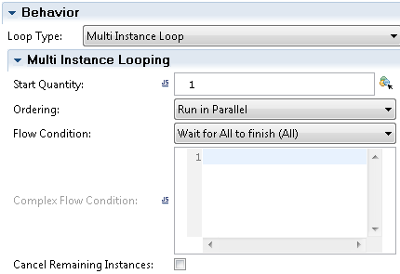
The Start Quantity field defines an expression of how many iterations to execute. The use of this phrase has caused puzzlement to some users. When we think "Start Quantity" we are sometimes drawn to the notion of "How many things do we start with?". What is really meant here is "What is the count (quantity) of things to start in total".
字段开始数量（Start Quantity）定义了需要执行的迭代次数。这个名称可能会有些误解。我们通常理解的“开始数量”指的是“有多少事情我们要开始？”。而其真正的含义是“总共有多少数量需要开始”。
Each iteration of the loop can find its own iteration index through the variable called:
循环的每次迭代都可以通过以下变量找到它当前的迭代索引值：
tw.system.step.counter
The ordering mode can be Run in Parallel or Run Sequential. When Run in Parallel is selected, the activities execute concurrently. When Run Sequential, the activities execute one after the other and the loop becomes a simple loop.
执行模式分为并行执行和时序执行两种。当选择并行执行时，活动可以并发执行。当选择时序执行时，活动将一个接一个地执行，这样跟简单循环类似。
When Run in Parallel is selected, the Flow Condition option becomes available. This determines when the activity as a whole is considered completed. The options are:
• Wait for All to finish (All)
• Conditional Wait (Complex)
当选中并行执行时，流程条件选项将变成可选。该选项决定整体的活动是否可以标记为完成。它包含以下选项：
- 等待所有完成（所有）
- 条件等待（复杂）
These options are shown here:
这些选项如下：
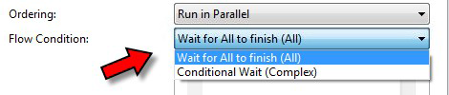

The Wait for All to finish means that all the activities must complete before the activity as a whole is considered complete.
等待所有完成意味着当一个整体活动标记为完成,所有的其他活动必须是完成的状态。
The Conditional Wait requires an expression to be supplied. When an activity completes, the expression is evaluated and the activity as a whole can be determined to have completed or not based on the value of the expression. If the expression is "true" then we end. If the expression evaluates to false, then the loop continues. The way that I like to think of the expression is as the answer to the question "Should we end the loop?".
条件等待需要提供一个表达式。当一个活动完成后，表达式已经完成计算，作为一个整体的活动可以确定为完成或者是没有基于表达式的计算结果。如果表达式的返回值为“True”，则结束。如果表达式结果为”False”，那么循环继续。那么当前表达式的结果的问题是，“我们应该结束循环吗？”。
If all the possible instances have completed, the loop as a whole will also complete irrespective of the outcome of the last condition.
如果所有的实例已经完成，整个循环也会变成完成的状态，无论最后一个循环的条件如何。
If a completion occurs as a result of the conditional wait expression, the Cancel Remaining Instances check box can be used to terminate any unfinished activities.
如果在等待条件表达式完成的过程中突然出现结束，复选框“取消剩余实例”可以用来终止任何未完成的活动。
When working with looping constructs, the variable called tw.system.step.counter contains the current loop indicator.The implementation types of a looping activity are as for any activity but not all of them make sense in this context. For example, the Sub-process is no more than a diagramming construct to replace a set of one or more BPD activities with a single BPD activity. The Sub-process executes in the BPD data context/scope and as such, has no differentiated variables associated with it. This means that each instance of a Subprocess started in parallel would have no distinction from others.
当使用循环结构时,变量tw.system.step.counter包含了当前循环的指标。循环的实现类型活动是可以用来表示任何的活动，但并非所有内容都是有意义的。例如，子流程不能使用超过一个图标构造来答题一组一个或者多个BPD活动。子流程是在BPD里头执行的数据内容/范围。因此，并没有区分相关联的变量。这意味着每个子流程实例可以并行执行，它们之间是没任何区别的。

遍历一组数据类型 - Looping through a map data type
We can use a Multi Instance loop to iterate through a Map object (see: Data Type – Map).
Assuming that the variable tw.local.myMap is a Map … set the Start Quantity field to be
tw.local.myMap.size(). In the Data Mapping section, we pass in the input to each of the service instances or sub-process instances. To supply data to those, use:
我们可以使用一个多循环实例来遍历一个Map对象（参考：数据类型 - Map）。假设变量tw.local.myMap是一个Map类型，将开始数量设置为tw.local.myMap.size()。在数据映射的部分，我们通过将数据参数传给每个服务实例或者子流程实例。提供数据的使用如下：
tw.local.myMap.valueArray()[tw.system.step.counter]
This line retrieves all of the values of the map and, for each value, starts a service/sub-process to
handle the processing of the data item.
改行获取map中的所有值，对于每一个值，启动相应的服务/子流程来对其进行数据处理。

BPD 图笔记 - BPD Diagram Notes
Notes are documentation items added to the BPD diagram. They appear as yellow rectangles into
which text can be entered. They have no operational semantics and do not affect the execution of
the process.
注释是添加在BPD图中的文档条目。他们是一些黄色的矩形文本输入框。它们饼没有操作语义，对流程的执行并没有任何影响。
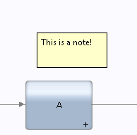
Notes can be positioned anywhere on the diagram canvas using the mouse to drag and drop them. They can be re-sized to any desired size. Unfortunately, there are no options to change the background color nor to have the text contained within wrap to the note size.
注释可以摆放在流程图的任意位置，可以通过鼠标来拖放它们。它们的大小可以进行任意的调整。但不幸的是，目前在改变注释大小的时候，不能修改背景颜色或者文本的内容。
One interesting way that notes have been seen to have been used is to place them over existing activities. Notes are always shown beneath activities so a note will never obscure an activity or sequence line. If the note is made larger than the activity, the effect can useful and pleasing:
关于注释的一个有趣的地方是，它可以被摆放在原有活动上。注释永远都是在活动的下方，饼不会遮盖活动或者连线。如果注释比活动大，这样看起来会比较美观和有效。
Don't forget that every activity has a Documentation section in which more details of that activity can be recorded. The difference between notes and documentation settings is that with notes, they are always visible while with documentation settings, the user has to explicitly examine the details of an activity to see more information.
对于每个活动，它有一个文档的选项，用来记录更多活动的细节。注释和文档的区别在于，注释永远是显示可见的，而文档则需要用户手动去点击文档选项来查看其细节。

流程和活动的完成时间 - Due dates for process and activities
Each process instance has the concept of a due date. This is the date and time when the process instance is desired to be finished. By having this forward date from when the process instance was created, we now know how close we are to risk of it not meeting some desired target.
每个流程实例都有完成时间的这个概念。这是一个流程实例计划完成的具体日期时间。通过这向前追溯到流程被创建的时间，我们可以清楚地知道这个流程不能如期完成的风险。
If the BPD Overview tab, we can set the "Due in" settings as shown next:
在BPD的概览项,我们可以配置“完成时间”如下：
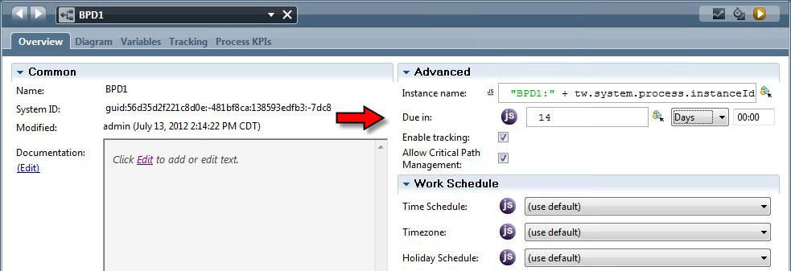
Similarly, we also have a corresponding set of details for each User Task in the the process:
同样的，对于不同的用户任务流程分配，我们有相应的细节配置：
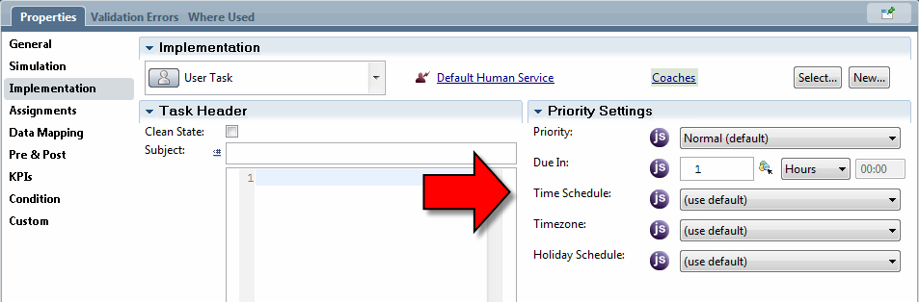
The default values for the work schedules are defined in the 99Local configuration file. In 8.5
they are:
任务安排的默认值是在99Local的配置文件中的。在8.5，它们定义如下：
<default-work-schedule>
<time-schedule>24X7</time-schedule>
<time-zone>CST</time-zone>
<holiday-schedule>empty holiday</holiday-schedule>
</default-work-schedule>
See also:
• Data Type – TWTimeSchedule
可以参考以下：
- 数据类型 - TWTimeSchedule

时间和假期安排- Time and Holiday Schedules
Consider a task being assigned to a user. Assume we say that it takes three hours of work to complete that task. If its 10:00am just now, then we can say that the time we expect the task to be completed will be 1:00pm which is three hours later. This means that the due date will be 1:00pm. But what if the same task is assigned at 4:00pm? Using simple arithmetic, we might say that the task is due to be complete at 7:00pm.
一个任务被分配给一个用户。假设我们说它需要花三个小时来完成这项任务。如果刚才的时间是早上10:00，那么我们可以说预计的任务完成时间是三个小时后的下午1:00。这意味着到期时间是下午1:00。但如果同一任务的分配时间是下午4:00呢？用这简单的算法，我们可以说该任务的完成时间是下午7:00。

